Interview with young female entrepreneur in Ung och Grön Sweden

Young farm shop Entrepreneur 1: Caroline Wahl Johansson: 073-8030650 komtillmotta@live.se www.torparelycka.se/

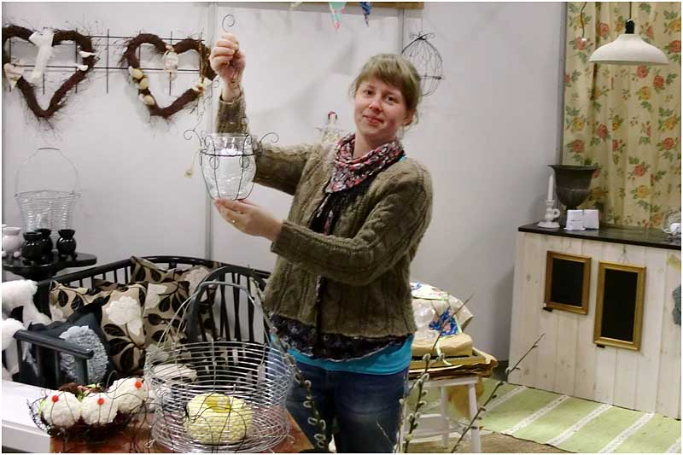

Kan du ge lite bakgrundsinformation om dig själv; alder, hur länge du har bott på landsbygden och vad du tycker om att leva där? Please provide some background information about yourself: your age, how long you have lived in the countryside, and what you like about living in a rural area/community?
I am 32 years old and have been living in this rural area since I was 5 years. My parents moved here from Stockholm without being connected to farming. Actually some relatives moved to this place first and many other relatives, including my parents followed the example.
For me a rural setting gives me space and it is quiet and peaceful. For my handicraft it is vital to be able to find both inspiration and material in the nature. Being able to get it from your own forest is a privilege.

Varför bestämde du dig för att starta ett eget företag? Why did you decide to set up your own business?
My in laws are running a farm and my husband has his own farming company with cattle. I started to think of it when I was at home on maternity leave with my children. I had this extra subsidy we can get after the maternity leave with, maybe a small, but nevertheless a base income every month. I wanted to be at home with my kids so a started to figure how I could combine a business at home with taking care of the children. Working with my handicraft is possible to do even with the kids around. Sometimes they even try a little themselves. I have a small cottage some km from our home which I use as a shop facility. My children can be with me when I am there as well. Quite close to the cottage there is a quite well known second hand and flea market, which attracts customers even to my handicraft. I both produce handicraft, sell some products form other craftsmen and also buy second hand items like furniture and fresh them up, painting them etc to sell them in a new shape. I am also a trained gardener so I offer services pruning trees and bushes.

Vilken hjälp har du fått genom projektet Ung och Grön? What help did you receive from the Green Entrepreneur scheme?

It was very valuable to meet with officers and advisors from both the authorities and the business service organizations and firms. I have used some of those contacts also after the course. And I can still call our project leader Petra and ask for help and advice when something comes up.
It was also useful to meet with other young entrepreneurial people sharing the idea of running a rural business. Just to see that others also had these kinds of ideas and dared to test them.

Vilka delar av ditt företag har en miljö-profil eller är särskilt miljövänliga? What aspects of your business are environmentally-friendly?

Since I am producing most of the handicraft myself and with much of the material from our forest it is really locally produced without any transports. Since I also am recycling much second hand furniture it adds to a more environmentally friendly profile. The products I buy from others are also from quite local producers so there are no imported goods with heavy transports.

Finns det några särskilda delar i Ung och Grön som har varit speciellt värdefulla och användbara för dig? Were there any aspects of the Green Entrepreneur scheme that you found particularly useful?
I would say that the contact with our project leader Petra was the single most valuable aspect of the Green Entrepreneurs scheme. I still call her from time to time.

Har du planer för att utveckla ditt företag ytterligare de kommande åren? Do you have any plans to further develop your business over the coming years?
I would like to develop my gardening service getting more customers. I got recently an entrepreneurship award from a political party´s women´s club so it gave some publicity. I have my shop open only the Saturdays, when people have time to come to my shop. But I have not developed any web shop yet, though I have a web site. There is also a balance between producing and selling. I have to get time to make the products. Maybe I can find a place closer to our home for my shop, depending if I want to have all the customers coming into my own garden.

