- Project Title

Close to nature forest management in the Bakony mountains

- Background

Slow-growing hardwood high forests in Hungary's Bakony mountains are in separate private holdings, some quite small. Differences in objectives, age classes and stand structures meant that annual felling volumes varied considerably, causing long-term deterioration of the forest.

The owners’ equipment was mostly second-hand and more than 10 years old, but income from the harvested timber did not cover the cost of new, more nature-friendly machinery. A project was designed to tackle the challenge.

- Objective(s)

The goal of this 10-year project is to create a balance between the long-term sustainability of almost 1 000 ha of hardwood forest and the local needs of the seven villages associated with the forest. There are three elements to this:
- Introducing a system of continuous cover silviculture with selective felling, so that the yield of timber is spread more evenly over the years; this will be better than traditional felling methods, both for the small owners and for the forest;
- Using modern transportation equipment, such as cableways and forwarders, that will be much less damaging to nature and the forest than the old methods;
- developing expertise and skills in modern forest management, and adopting these in the day-to-day working practices in the forest.
In this way the owners' short-term interests will be satisfied and in long-term there will be a higher yielding forest with a better environment and richer biodiversity.

- Main Activities

The work is split into sub projects which each require planning, purchase of equipment, basic tools, and other services. Professional staff were recruited and trained by Ihartü-2000 Ltd., and a monitoring and control system set up.

The field-work for a sub-project may run for several years or just one, but preparation and planning is always done a year ahead.

The project as a whole covers the costs of payments to forest owners, professional staff and training, IT equipment (computers, GPS, printer, GIS, software), services and databases (forest stand data, cadastral records) and the modern logging tools and forwarders to work the forest.

- Results and Benefits

Changing a large forest to a selective felling system is a slow process that takes up to 60 years to complete, but early results are evident in the favourable perceptions of forest owners, the modernisation of forestry machinery, and the experience of implementing an unfamiliar management regime.

The benefits of nature-friendly transportation can be seen already in the forest and among the workforce. Using modern technology and machinery to haul the felled timber out of the forest means there is much less damage to the trees and the soil than there was with the old methods.

- Lessons Learned

The forest owners found the process of applying for forest-environment payments difficult and bureaucratic. This, together with delays in approving applications and making payments, is making it more difficult to persuade the owners to become involved. The administrative requirements were very complicated for costing some types of environmental management, for example using manual labour and hand tools to establish native tree seedlings following regenerative felling.

In future, the forest owners would like to see a less complicated and more timely application and payment process.

- EAFRD Measure

225 Forest Environment Payments

- Total Project Cost

Payments of €164/ha/year for 10 years to forest owners for management by selective felling (for 957 ha of forest a total of €1 568 988 over the 10 years).

Payments of €12.45/cubic metre of timber for nature-friendly transportation (at an average of 12 000 cubic metres per year, a total of €1 494 000 over the 10 years,).

Note: this does not include RDP payments to Ihartü-2000 Ltd. for administering the whole project.

- EAFRD Contribution

77%

- National Contribution

33%

- Private Contribution

Nil (payments are intended to cover 100% of the costs to owners)

- Project duration

Start date (31/10/10)
End date (31/10/20)

- Photographs

P1010789 – young beech seedlings growing in a small felled area (photo by Bodor Dezső Károly)
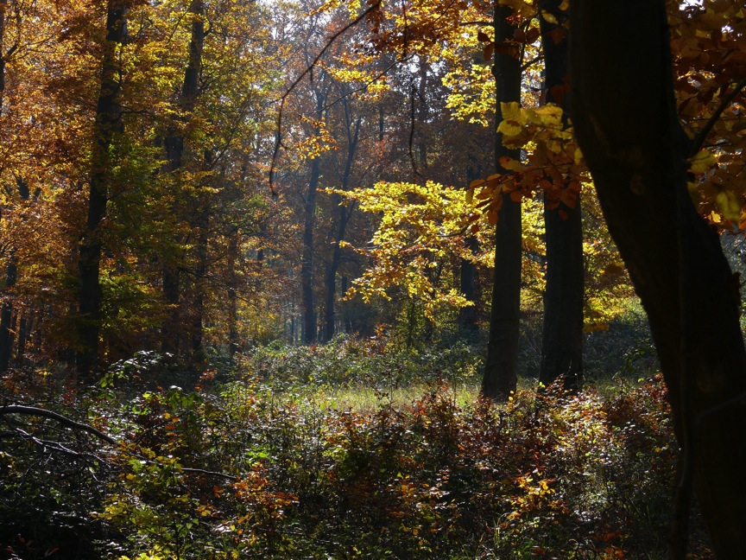

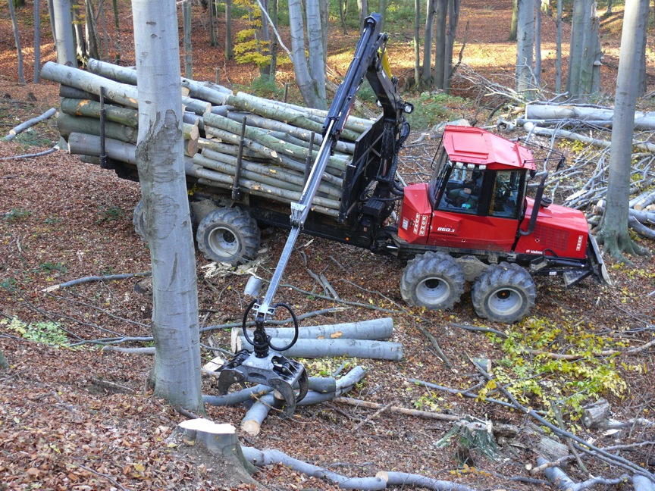
P1030479 nature-friendly transportation of timber (photo by Bodor Dezső Károly)

