Personal comments of beneficiary
Q1 Why was the EAFRD project funding important for your business/organisation/area?
“The EAFRD is one of the few funds we can apply to for this kind of work. For SSSIs [nationally designated biodiversity sites] this is the funding source that is most relevant. We are committed to ensuring that the SSSI is in favourable condition and this assists us in doing so.”
Gill Smart, Scottish Wildlife Trust Reserves Manager, South West Scotland
Q2 What types of benefits has the project created (business, social and environmental)?
“Knowing we had this funding secured for a four years period allowed us to plan ahead. Staff were freed from fundraising work for other useful activities.
Keeping the reserve’s access provision in good condition benefits our reputation with visitors to it. Demonstrating best practice is one of our organisations objectives.
The full environmental benefits will be detectable in the long term but a reduction in invasive aliens and non-native trees can already be seen. Native tree seedlings are appearing already”
Gill Smart, Scottish Wildlife Trust Reserves Manager, South West Scotland
Q3 How are you measuring the success of your project (as a medium and long-term investment)?
“People-counters record the number of people that use the footpaths.
National Vegetation Classification surveys are carried out in a ten year cycle (approximately). These indicate the quality of the woodland.
Site Condition Monitoring surveys of the woodland condition and invertebrate assemblage are undertaken on a similar cycle.”
Gill Smart, Scottish Wildlife Trust Reserves Manager, South West Scotland
Q4 Do you have any plans for new rural development projects linked to this one?

Yes. Actions such as alien control and non-native tree removal are by their nature ongoing, if at a reduced level. We anticipate further access and biodiversity improvements.
Gill Smart, Scottish Wildlife Trust Reserves Manager, South West Scotland

Four images (here and as separate files):

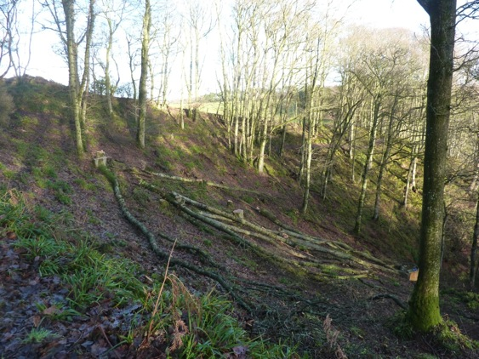
Photo 1: small scale thinning of oak; shows felled oak trees in small clearing; acknowledge G Smart

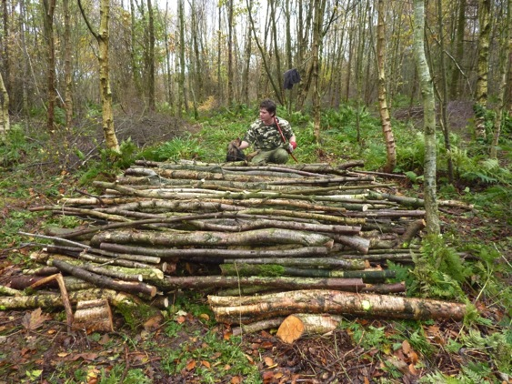
Photo 2: dead wood management; shows stems from re-spacing being used to create a habitat feature; acknowledge G Smart

Photo 3: fungal foray; shows people enjoying a fungal foray; acknowledge G Smart
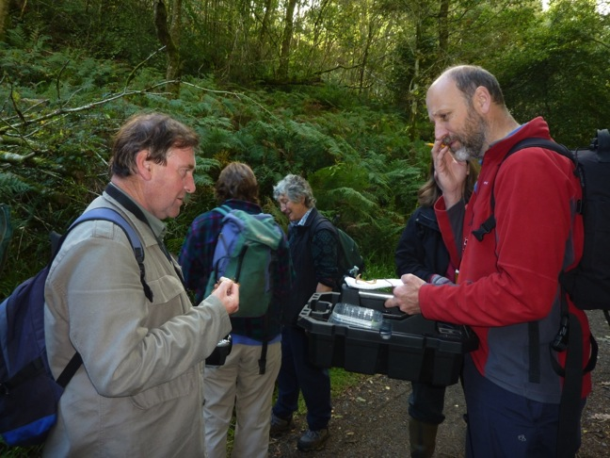

Map of Ayr Gorge Woodland SRDP Projects as a JPG file

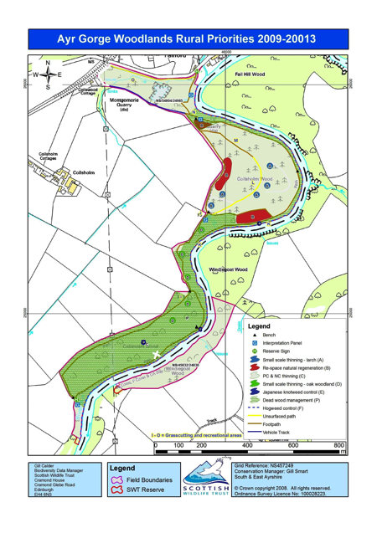

Find out more at: http://scottishwildlifetrust.org.uk/reserve/ayr-gorge-woodlands/

