Interview with for young male equestrian entrepreneur in Ung och Grön Sweden

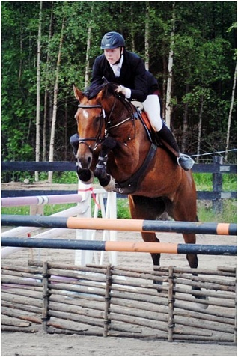

Young equestrian entrepreneur 2: Joakim Didrik +46 70 3353620 jocke.didrik@hotmail.se www.stallattingen.se

Please provide some background information about yourself: your age, how long you have lived in the countryside, and what you like about living in a rural area/community?

I am 20 years old and born on a farm in the village of Haddås in Ekdsjö municipality. My parents have not been traditional farmers but we have some 100 ha of forest and 20 ha of arable land. We have always had horses, both our own and also from people hiring a place in our stable. So I am born into the idea of offering horse owners a stable with food and also help with training of the horses if needed.

For me I have chosen to stay and form a company in a rural area because I like it here and I want to show that it is possible to live in a rural area and both run and develop a business here. With my interests and the focus of my company it is of course an advantage to live in a rural. area. My motto is “Nothing is impossible, there are always some possibilities”

Why did you decide to set up your own business?
My Dad has always been running his business with the farm and forestry. We have been talking now and then about me starting my own business with horse training. The project leader of the Green Entrepreneur Scheme Petra Svensson is a friend in the family so when she called and offered the courses in the scheme I was enthusiastic and my parents backed me up.

For several years I have helped my parents with the horses and have also started to compete in horse jumping. Last June I completed secondary school with education as an electrician and have now an employment for a company installing electricity in constructions. I want to work there at least the 1600 hours needed to get a certificate. At the same time, starting autumn 2010, I have participated in the Green Entrepreneur Scheme. With my certificate as an electrician I can combine working as an employee and bit by bit build my horse based business. It gives an economic security. I am also competing in horse jumping at quite a high level so I have the horses both as an interest and a hobby as well as a possible business.

What help did you receive from the Green Entrepreneur scheme?
I received a lot of positive feedback on my ideas for business both from the project leader and from the other participants. It gave me the courage to take the steps to start a business. We have also got a lot of good advice about how to find funding, apply for investment grants. We had lecturers from the Tax Agency and the consultancy firm LRF Konsult. The state owned business funding institute ALMI was also there. All this gave us a good view of hurdles and possibilities and things you have to think of and do when starting a business. Of course we also got information about advertising, business plans etc. Since many in the group knew each other since before it was easy to share the different ideas and questions about the business ideas.

Our project leader has been very important and she is still available for us if any question or problem show up. When the LRF business consult gave her lecture she also offered a two hours consultancy time free of charge. This has for me led to a continued contact for advice, which has helped me.

What aspects of your business are environmentally-friendly?
The farm of my parents, where all the ensilage and hay for the horses are produced, is strictly organic.

Were there any aspects of the Green Entrepreneur scheme that you found particularly useful?
The boost of the self-esteem and confidence we got in the course both from the project leader and from the other participants was really important. Being aware that you can test a business idea and even fail but you are not put in jail. Our project leader Petra has been really positive and coaching. Secondly it has been very helpful to get in touch with all these advisors and I have also got a very good bank contact.

Do you have any plans to further develop your business over the coming years?
I have no big development plans for the near future. I think I need to grow slowly. During summer it can be some more business activities. I will try to get more and more customers so I can phase out my employment during some years. Then it might be time to make an investment in more horse boxes and even a larger riding hall. There is a building at the farm that I might be able to change into a riding hall. My marketing is through man to man or customer to friends but also through the competitions where I participate where my name and business is mentioned. I have also a web site at www.stallattingen.se

